Testcase validates:

* One record in **D_PI_PRIMARY_PRESENCE_VW corresponds to multiple records in D_PI_PRIMARY_PRESENCE_DAILY_DURATION_VW**
* Daylight conversion
* In **D_PI_PRIMARY_PRESENCE_DAILY_DURATION_VW data in column** PROJECTPRESENCEENDTIME ends in .59.59.00 and starts at 00:00:00.000 next day
* **DURATION** calculation

Table: **D_PI_PRIMARY_PRESENCE_VW**

Query:

select PROJECTID, USERID, PRESENCESTARTDATE, DURATION, ORGANIZATIONPRESENCE, PRESENCESTARTTIME, PRESENCEENDTIME, SYSTEMPRESENCE

select PROJECTID, USERID, PRESENCESTARTDATE, DURATION, ORGANIZATIONPRESENCE, PRESENCESTARTTIME, PRESENCEENDTIME, SYSTEMPRESENCE

from "PUREINSIGHTS_DEV"."PUBLIC"."D_PI_PRIMARY_PRESENCE_VW"

where PROJECTID = 5555 and PROJECTNAME = 'COVERVA'

and userid = '797d2f73-5f02-4939-b6ea-86b44b4d7698'

and ORGANIZATIONPRESENCE = 'Offline'

and PRESENCESTARTDATE >= '2021-03-01'

and PRESENCESTARTDATE <= '2021-03-02';

Data:

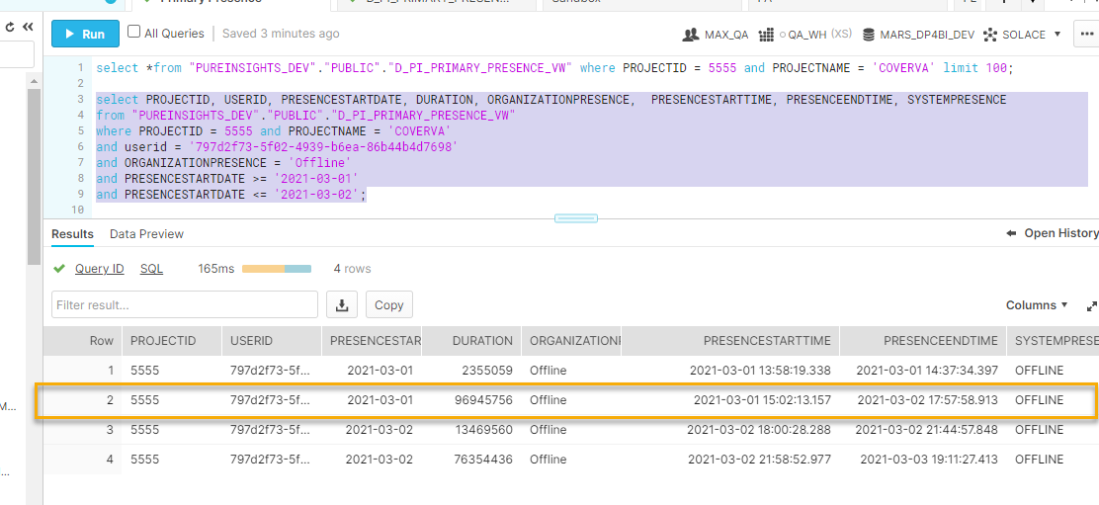

Table: **D_PI_PRIMARY_PRESENCE_DAILY_DURATION_VW**

Query:

select PROJECTID, USERID, PROJECTPRESENCESTARTDATE, PROJECTPRESENCESTARTTIME, PROJECTPRESENCEENDTIME, SYSTEMPRESENCE, DAILYDURATION, TOTALDURATION

from "PUREINSIGHTS_DEV"."PUBLIC"."D_PI_PRIMARY_PRESENCE_DAILY_DURATION_VW"

where PROJECTID = 5555 and PROJECTNAME = 'COVERVA'

and USERID = '797d2f73-5f02-4939-b6ea-86b44b4d7698'

and SYSTEMPRESENCE = 'OFFLINE'

and PROJECTPRESENCESTARTDATE >= '2021-03-01'

and PROJECTPRESENCESTARTDATE <= '2021-03-02';

Data:

